Image | 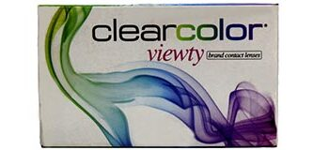
Brand | DIOR
Model Name | CLEAR COLOR
Price | RS 5500
PRODUCT DETAILS

